HCI101 PROJECT DEVELOPMENT

INTERACTION DESIGN IN JAVASCRIPT WITH LOCAL STORAGE

**By: Team 4**

**UX AUDITS**

**Menu Makeover: A UX Audit of Menulog's** 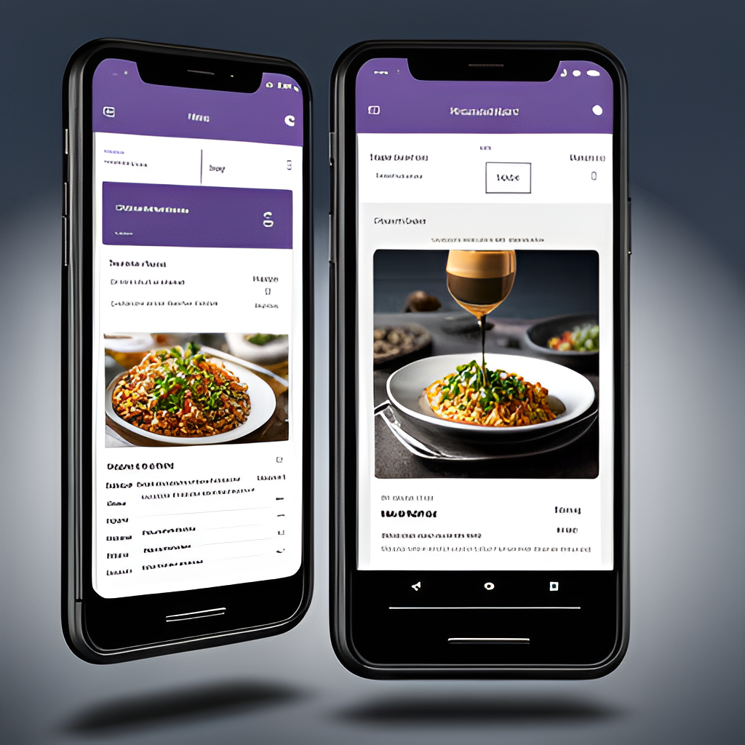

**Introduction**

In today's digital age, a website is often the first point of contact between a business and its customers. It is essential for businesses to ensure that their website provides an optimal user experience (UX) to attract and retain customers. This is where UX audits come in. A UX audit is a comprehensive analysis of a website's usability, accessibility, and overall user experience.

In this presentation, we will be conducting a UX audit of the Menulog website. Menulog is an online food delivery service that allows customers to order food from a variety of restaurants. The website plays a crucial role in the company's success, and it is important to ensure that it provides an excellent user experience to its customers.

**Homepage**

The homepage is the first impression that a customer has of the website. It should provide a clear understanding of what the website offers and how to use it. Upon visiting the Menulog homepage, the first thing that stands out is the search bar. It is prominently placed at the top of the page, making it easy for customers to find what they are looking for.

However, the homepage could benefit from more visual elements. Currently, it consists mostly of text and lacks engaging images or videos. Adding these elements could make the homepage more visually appealing and help to keep customers on the site for longer periods of time.

**Navigation**

Navigation is an essential element of any website, and it is particularly important for an online food delivery service like Menulog. Customers need to be able to easily navigate the website to find the food they want to order. Menulog's navigation is straightforward and intuitive. The main categories are listed at the top of the page, and subcategories are listed in drop-down menus.

One area for improvement would be to make the navigation more mobile-friendly. Currently, the drop-down menus do not work well on mobile devices, which could frustrate customers trying to place orders on-the-go. Improving the mobile navigation would make the website more accessible and user-friendly for all customers.

**Ordering Process**

The ordering process is the most critical part of the Menulog website. It needs to be easy to use and understand to ensure that customers can quickly and efficiently place their orders. Menulog's ordering process is relatively straightforward. Customers select the restaurant and food they want to order, add items to their cart, and then check out.

However, there are a few areas where the ordering process could be improved. For example, the checkout process could be streamlined to reduce the number of clicks required to complete an order. Additionally, the website could benefit from providing more information about delivery times and fees upfront to avoid surprises at checkout.

Based on these findings, there are several recommendations for improving the user experience on Menu log’s website:

1. Add a search bar on the homepage to allow users to easily find specific restaurants or dishes.
2. Provide more options for customizing orders and adding special instructions.
3. Display the estimated delivery time on the order confirmation page.
4. Simplify the design and reduce clutter on the restaurant pages.
5. Improve response times and issue resolution for customer service inquiries.

.